 | National University of Science and Technology POLITEHNICA Bucharest  Electrical Engineering Faculty | 

MASTER THESIS

Title in ENGLISH

(Title in ROMANIAN- Mandatory)

Graduate: [Name SURNAME]

Scientific Coordinator: [Academic rank Name SURNAME]

THIS BORDER (TEXTBOX) WILL BE DELETED!

The red text has an informative/explanatory role and will be replaced by a black text specific to the thesis carried out WITHOUT being put between square brackets!

BUCHAREST

[year of the graduation]

Content

0.1. Demonstrative text 3
0.2. Demonstrative text 3
Chapter 3 – The title of the Chapter 3 4
3.1. Demonstrative text 4
Appendix 1 – The name of Appendix 1 5
References 6

The table of contents is generated automatically if any main chapters (I, II, III) are selected as Titles and each subchapter (I.1, II.3, etc.) is selected as subtitle.
Later, Update is given on the table of contents.

In this example the titles and subtitles are of this form

Introduction

0.1. Demonstrative text

Demonstrative text. A varying current in the transformer's primary winding creates a varying magnetic flux in the transformer core, which is also encircled by the secondary winding Fig. 1.1 [Wik 13]. This varying flux at the secondary winding induces a varying electromotive force or voltage in the secondary winding. This electromagnetic induction phenomenon is the basis of transformer action and, in accordance with Lenz's law, the secondary current so produced creates a flux equal and opposite to that produced by the primary winding.

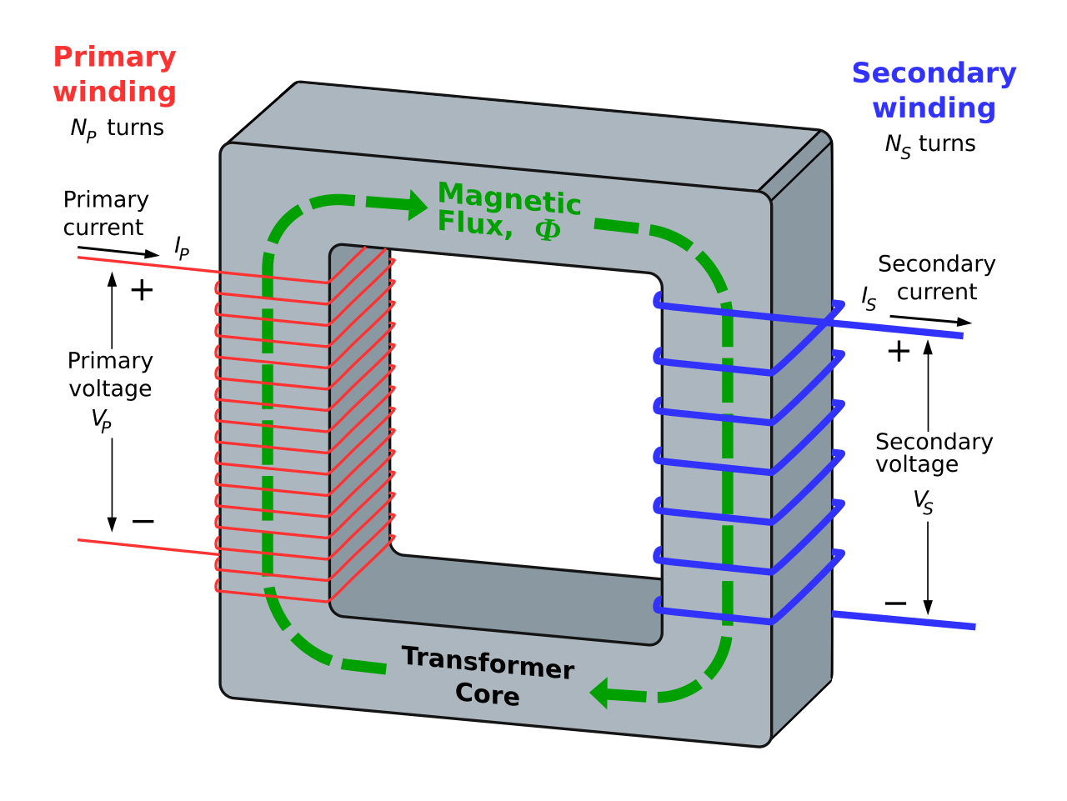

Fig. 1.1 – Transformer operating principle.

Demonstrative text.

0.2. Demonstrative text

Demonstrative text.

Chapter 3 – The title of the Chapter 3

3.1. Demonstrative text

Demonstrative text. [Ghi 1], [Ghe 1]:

$\begin{aligned}\left\{u_{1}=R_{1}⋅i_{1}+\frac{{dΦ}_{1}}{\text{dt}} | \right.\end{aligned}$ (3.1)

where: $R_{1}$, $R_{2}$ – primary and respectively secondary windings resistances, and $Φ_{1}$, $Φ_{2}$ – represents the total fluxes that cross the two windings with $w_{1}$ of the primary windings turs and $w_{2}$ the secondary winding turns.
In Tab. 3.1 is a demonstrative text

Tab. 3.1 – demonstrative text.

$$γ_{R}$$ | ° | 6 | 33 | 57 | 70 | 87
$${\hat{i}}_{1_{{\text{mas}}_{R}}}$$ | A | 96,1 | 80,1 | 38 | 21 | 15.5
$${\hat{i}}_{1_{{\text{sim}}_{R}}}$$ | A | 96,6 | 80,7 | 38,7 | 20,4 | 14,8
$$γ_{\text{RL}}$$ | ° | 187 | 19 | 39 | 72 | 86
$${\hat{i}}_{1_{{\text{mas}}_{\text{RL}}}}$$ | A | -91 | 88.5 | 71 | 11 | 8,2
$${\hat{i}}_{1_{{\text{sim}}_{\text{RL}}}}$$ | A | -92,8 | 89 | 71,1 | 10,8 | 7,5

Demonstrative text

3.1.1. Demonstrative text

Demonstrative text

3.1.2. Demonstrative text

Demonstrative text

Appendix 1 – The name of Appendix 1

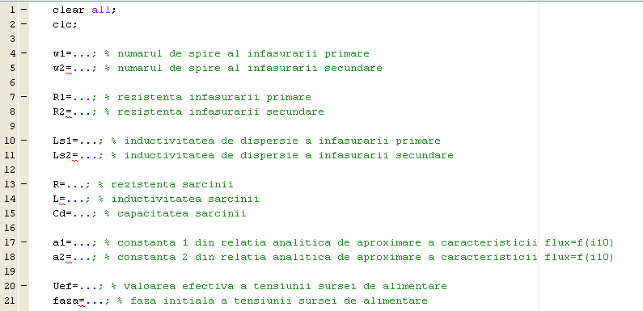

Fig. A1.1 – Demonstrative text
.

References

[Chi 1] – Popescu A.-I., Mitrică I.-D., Ghiţă C., Iustin V., Aplicarea metodei elementului finit pentru determinarea câmpului electromagnetic dintr-un transformator electric trifazat, Revista Electrotehnică Electronică Automatică (EEA), Volumul 55, Numărul 1, Ianuarie-Martie, Editura Electra, Editor S.C. ICPE S.A., pag. 39-46, 2007.
[Dea 1] – Popescu I.-D., Mitrică A.-M., Ghiţă A.-I., Priboianu M., Ionescu V., Transitory regimes analysis methods for electrical transformers, The 6TH International Conference on Electromechanical and Power Systems (SIELMEN 2007), Analele Universităţii din Craiova, Seria Inginerie Electrică, Anul 31, nr. 31, Vol. II, Editura Universitaria, ISSN 1842-4805, pag. 295-300, 2007.
[Dea 2] – Popescu A.-I., Mitrică I.-D., Ghiţă C., Iustin V., Analytical computation method for electrodynamic forces acting over electrical transformer windings, U.P.B. Scientific Bulletin, Series C – Electrical Engineering, Volume 71, Iss. 2, pag. 143-154, 2009.
[Wik 13] – Transformatorul - From Wikipedia, the free encyclopedia [online]. [2019] [citat 27.07.2019]; Disponibil la: URL: https://ro.wikipedia.org/wiki/Transformator

